# Required Items

|  |  |  |  |
| --- | --- | --- | --- |
| Reference | Material | Dimensions (mm) | Quantity |
| Design Components | | | |
| R01 | AK 10-9 BLDC Motor | Refer manufacturer datasheet | 1 |
| R02 | Motor Mount | - | 1 |
| R03 | Motor Base Plate (bottom) | - | 1 |
| R04 | Motor Base Plate (top) | - | 1 |
| R05 | Motor Mount Base Plate | - | 1 |
| R06 | Motor Mount Backing Plate | - | 1 |
| R07 | Motor Shaft | - | 1 |
| R08 | Driving Pulley | - | 1 |
| R09 | Driving Pulley Taper Bushing | - | 1 |
| Fasteners | | | |
| F01 | Hex Flange Head Screw | M6 × 1 × 65 | 14 |
| F02 | Hex Flange Head Screw | M5 × 0.8 × 45 | 4 |
| F03 | Hex Flange Nut | M5 × 0.8 | 10 |
| F04 | Hex Flange Nut | M6 × 1 | 18 |
| F05 | Hex Nut | M6 × 1 | 14 |
| F06 | Hex Nut | M5 × 0.8 | 8 |
| F07 | Hex Socket Head Screw | M5 × 0.8 × 20 | 6 |
| F08 | Hex Socket Head Screw | M4 × 0.7 × 10 | 14 |
| F09 | Grub Screw | M4 × 10 | 4 |
| F10 | Grub Screw | M5 × 12 | 2 |
| F11 | Spring Washer | M4 | 6 |
| F12 | Inserts | Refer UTSMA files. | 14 |
| Tools | | | |
| T01 | Torque wrench | Via preferred manufacturer,  (suited for) size ranges:  M3 – M6 | 1 |
| T02 | Sockets & extension set | 1 |
| T04 | Hex (Allen) key set | 1 |
| T05 | Adjustable spanner | Via preferred manufacturer | 1 |
| T06 | Scissor Lift | Via preferred manufacturer | 1 |
| T07 | Hydraulic jack | Via preferred manufacturer | 1 |

Table of Contents

Required Items 0

S01 – Motor & Base Plate SA1 2

S02 – Motor Mount SA2 3

S03 – Motor Mount & Base Plate SA3 4

S04 – Motor & Motor Mount SA4 5

S05 – Motor & Motor Mount SA5 6

S06 – Motor Shaft Installation SA6 7

S07 – Pulley Preparation SA7 8

S08 – Pulley Installation SA8 9

S09 – Fastener Installation SA9 10

S10 – Insert Installation SA10 11

S11 – Insert Installation SA11 12

S12 – Backing Plate Installation SA12 13

S13 – System Clamping SA13 14

Nomenclature & Document Navigation 15

Reference Codes & Terminology 15

# S01 – Motor & Base Plate SA1

|  |  |  |  |
| --- | --- | --- | --- |
| Reference | Material | Dimensions (mm) | Quantity |
| R01 | AK 10-9 BLDC Motor | - | 1 |
| R03 | Motor base plate (bottom) | - | 1 |
| F08 | Hex Socket Head Screw | M4 × 0.7 × 10 | 4 |
| F09 | Grub Screw | M4 × 10 | 2 |

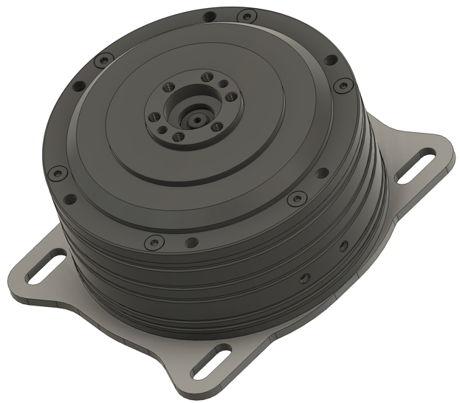 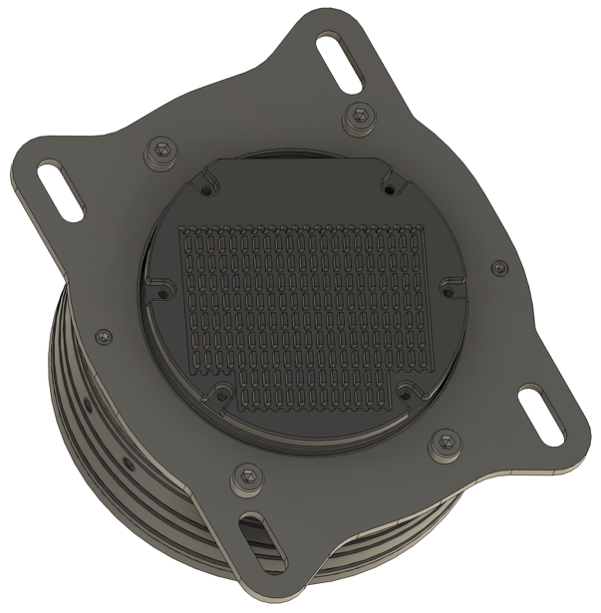

1. Obtain the BLDC motor.
2. Rotate it to face the underside of the motor.
3. Obtain the base plate (**R03**)
4. Press **R03** against the bottom face of **R01**.
5. Align the hole sequence on **R03** with that of **R01**, whilst following step 4.
6. Identify the threaded and the non-threaded holes on **R03**.
7. Obtain hex key compatible with *M3* socket head.
8. Twist **F08** through the non-threaded holes located on the bottom face of the motor.
9. Twist **F09** through the threaded holes located on the bottom face of the motor.
10. Ensure both two grub screws always are closest to the perimeter of **R03**.
11. Fully tighten **F08** & **F09** along the threaded holes located on the bottom face of the motor.
12. Ensure that **R03** firmly bonded on to the motor.
13. Rest this subassembly horizontally, with the top of **R01** facing upwards.
14. Set it aside.

# S02 – Motor Mount SA2

|  |  |  |  |
| --- | --- | --- | --- |
| Reference | Material | Dimensions (mm) | Quantity |
| R02 | Motor Mount | - | 1 |
| F01 | Hex Flange Head Screw | M6 × 1 × 65 | 4 |

1. Obtain the motor mount (**R02**)
2. Orientate **R02** with the underside facing towards you.

Note: The incline plane is your mounting surface at this stage of the subassembly.

1. Locate the four (threaded) *M5* holes on the inclined plane on the motor mount.
2. Gather the given quantity of **F01**.
3. Insert the screw into a chosen thread.
4. Screw until the entire fastener passes through.
5. Retrieve a torque wrench equipped with a *M5* insert
6. Fully tighten the bolt head against the mounting surface.
7. Repeat steps 4 – 8, for the remaining three holes.

# S03 – Motor Mount & Base Plate SA3

|  |  |  |  |
| --- | --- | --- | --- |
| Reference | Material | Dimensions (mm) | Quantity |
| R05 | Motor Mount Base Plate | - | 1 |
| F03 | Hex Flange Nut | M5 × 0.8 | 6 |
| F07 | Hex Socket Head Screw | M5 × 0.8 × 20 | 6 |
| S02 | Motor Mount SA2 | - | 1 |

1. Acquire the Motor Mount Base Plate (**R05**) and lay it down horizontally.
2. Find the topside of the plate and face it towards you, this is your mounting face.
3. Locate the (six) hole pattern present underneath the mounting flanges of **R02**,
4. Align this pattern against that of the six (threaded) *M5* holes on mount base plate.
5. Note: Ensure the hole pattern on the mounting flanges of **R02** is aligned against that of **R05**.
6. Once aligned, collect one screw from **F07** and thread it through a selected hole.
7. Retrieve a hex key compatible with *M5* bolt heads.
8. Twist the bolt into place, until fully secure.
9. Repeat steps 1 – 8, for the remaining 5 holes.
10. Rotate the subassembly upside down.
11. Locate and face the underside of the plate, where the (**F06**) bolts protrude.
12. Collect one of **F03**.
13. Twist the nut along the bolt, until the bottom face of **R05**.
14. Retrieve a spanner compatible with an *M5* bolt head.
15. Fully tighten the nut.
16. Repeat steps 11 – 15, for the remaining 5 bolts.

Note: By the end, the motor mount must be fully clamped to the motor mount base plate.

# S04 – Motor & Motor Mount SA4

|  |  |  |  |
| --- | --- | --- | --- |
| Reference | Material | Dimensions (mm) | Quantity |
| F06 | Hex Nut | M5 × 0.8 | 4 |
| S01 | Motor & Base Plate SA1 | - | 1 |
| S03 | Motor Mount & Base Plate SA3 | - | 1 |

1. Obtain **S01** and face the top of the motor.

Note: Decide the direction, to face the ports underneath the motor. Either front/back.

1. Align the four slotted holes on **S01** against the *M5* bolts on the inclined mounting plane.

Note: The bolts of **S03** must be able to pass vertically through the slots of **S01**.

1. Ensuring the top face of motor is facing you, gently drop **S01** along the bolts and let it sit freely on the Motor Mount (**S02**) .
2. **R03** must now sit flush against the raised mounting face of **S02**.
3. Collect one **F06**  and twist it along a chosen bolt on **S03**.
4. Twist until the nut approximately 10 mm away (along the negative z axis) from the tip of the bolt.
5. Repeat step 4 – 5, for remaining 3 bolts on **S03**.

# S05 – Motor & Motor Mount SA5

|  |  |  |  |
| --- | --- | --- | --- |
| Reference | Material | Dimensions (mm) | Quantity |
| R04 | Motor Base Plate (top) | - | 1 |
| F04 | Hex Flange Nut | M6 × 1 | 4 |
| F08 | Hex Socket Head Screw | M4 × 0.7 × 10 | 4 |
| F09 | Grub Screw | M4 × 10 | 2 |
| S04 | Motor & Motor Mount SA4 | - | 1 |

Bonding the top base plate to motor

1. Obtain the base plate (**R04**) and press it against the top face of **R01**.
2. Rotate base plate.
3. Align the hole pattern on **R04** with that of **R01**.
4. Firmly hold **R04**to the motor while following step 3.
5. Identify the threaded and the non-threaded holes on **R04**.
6. Obtain the appropriate hex key.
7. Twist **F08** through the non-threaded holes located on the bottom face of the motor.
8. Twist **F09** through the threaded holes located on the bottom face of the motor.
9. Ensure the two grub screws always are closest to **F04**.
10. Locate the portion of the 4 threaded bolts (**F08**) that emerge from the four slots.
11. Pass each **F04** through each bolt, twisting until handtight.
12. Anticlockwise, twist each hex nut underneath **R04**, until hand tight.
13. Obtain a spanner compatible with an *M6* bolt head.
14. Proceed tighten each **F09** against **F08** until they tightly clamp **R04**.

# S06 – Motor Shaft Installation SA6

|  |  |  |  |
| --- | --- | --- | --- |
| Reference | Material | Dimensions (mm) | Quantity |
| R07 | Motor Shaft | - | 1 |
| F04 | Hex Flange Nut | M6 × 1 | 4 |
| F08 | Hex Socket Head Screw | M4 × 0.7 × 10 | 6 |
| F11 | Spring washer | M4 | 6 |
| S05 | Motor & Motor Mount SA5 | - | 1 |

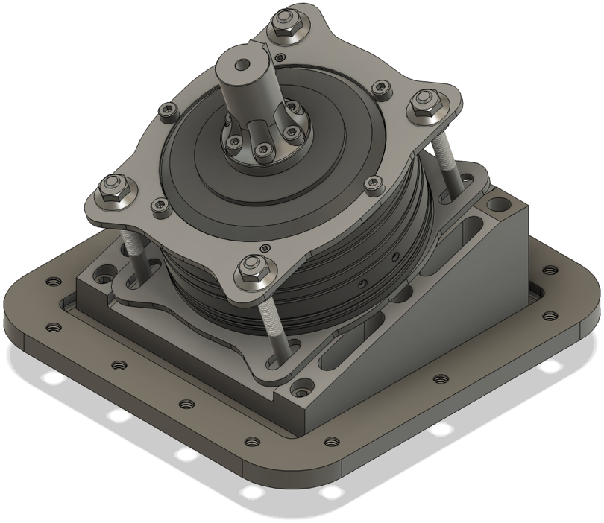

1. Obtain the motor shaft and position its base on the motor flange.
2. Collect the six, *M4* spring washers (**F11**).
3. Align the hole pattern on the base of **R07** against that of the motor flange.
4. Hold the motor shaft in this position.
5. Deposit a spring washer into a chosen circular indent, on the hole pattern of R06.
6. Insert a **F08** into this hole and use the hex key to twist the screw until **F11** is fully compressed.
7. With a quarter clockwise turn, investigate whether the screw is fully locked into the thread.
8. Repeat steps 1 – 7, until the base of **R07** has been completely bonded on to the motor flange.

# S07 – Pulley Preparation SA7

|  |  |  |  |
| --- | --- | --- | --- |
| Reference | Material | Dimensions (mm) | Quantity |
| R08 | Driving Pulley | - | 1 |
| R09 | Driving Pulley Taper Bushing | - | 1 |
| F10 | Grub Screw | M5 × 12 | 2 |

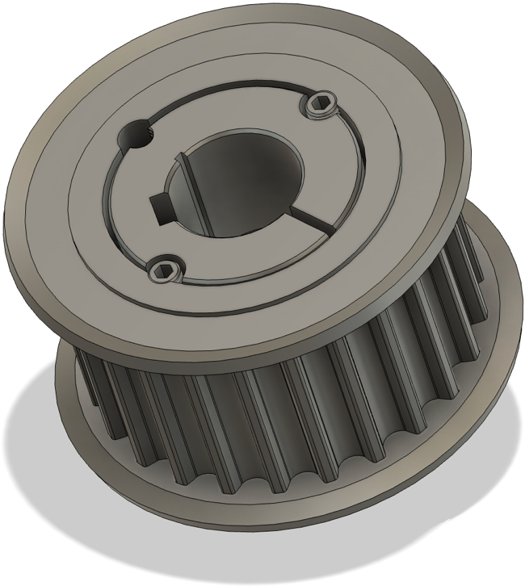

1. Obtain **R08** & **R09.**
2. Ensure **R08** & **R09** are clean and free of grease or debris.
3. Align the taper bushing with the tapered bore of the pulley.
4. Gently slide the bushing into the pulley, ensuring a snug and even fit.
5. Match the holes on the pulley with the corresponding holes on the bushing.
6. Gather a pair of *M5* grub screws (**F10**).
7. Insert the each **F10** into each threaded hole of the taper bushing.
8. Obtain a *M5* compatible hex key.
9. Partially tighten both grub screws to draw the bushing slightly into the pulley.
10. Set this subassembly aside.

# S08 – Pulley Installation SA8

|  |  |  |  |
| --- | --- | --- | --- |
| Reference | Material | Dimensions (mm) | Quantity |
| S06 | Motor Shaft Installation SA6 | - | 1 |
| S07 | Pulley Preparation SA7 | - | 1 |

1. Inspect the keyway on the motor shaft (**R06**) and align it with the keyway on the R08.
2. Slide **S07** onto the motor shaft.
3. Adjust the position of **S07** on the motor shaft.
4. Obtain a digital inclinometer.
5. Verify that the pulley is level and correctly oriented along the motor shaft.
6. Gradually tighten the grub screws in a crisscross pattern using the appropriate hex key or wrench.
7. Obtain a M5 compatible torque wrench and extension.
8. Tighten each screw incrementally until the specified torque, as per the manufacturer’s guidelines.
9. Retrieve the digital inclinometer.
10. Recheck the pulley alignment to confirm it hasn’t shifted.
11. Verify that the pulley is firmly seated on the bushing.
12. Ensure that the bushing is securely locked onto the required location along R06.
13. If applicable, activate the motor to rotate the shaft, thereby **S07**.
14. Check the rotation of **S08** for smooth movement and any potential misalignments.
15. Redo steps 6 – 11 if further adjustments are required.
16. Orient the subassembly as depicted by the image above.

# S09 – Fastener Installation SA9

|  |  |  |  |
| --- | --- | --- | --- |
| Reference | Material | Dimensions (mm) | Quantity |
| F01 | Hex Flange Head Screw | M6 × 1 × 65 | 14 |
| S08 | Pulley Installation SA8 | - | 1 |

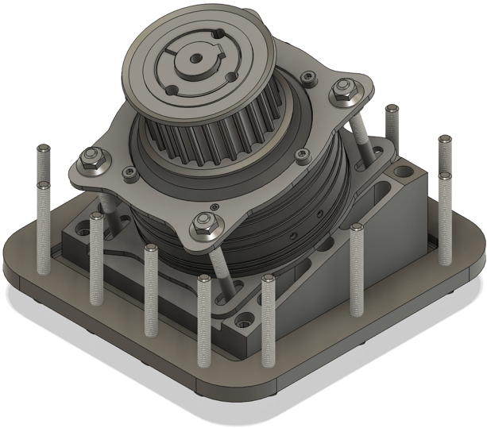 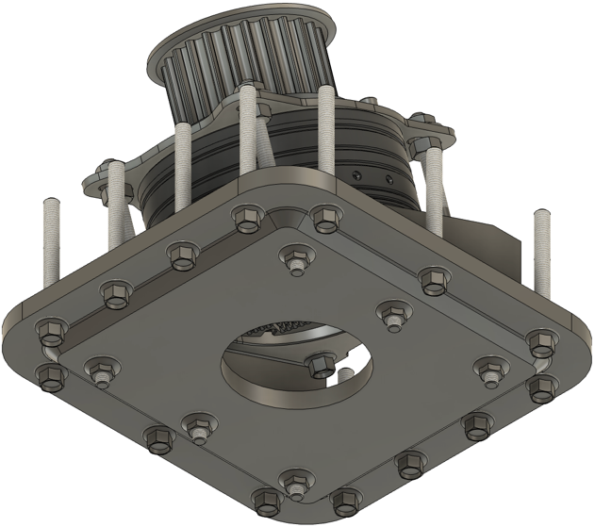

1. Obtain **S08** and place it above a flat surface.
2. Identify the (unoccupied) threaded hole pattern that lies along the outline of the **R05**.
3. Obtain a *M6* hex flange head bolt.
4. Starting from the underside of **R05**, insert and twist the bolt () along one of selected threads on this pattern.
5. Obtain a spanner compatible with *M6* bolt heads.
6. Twist the bolt until the bolt flange is firmly flush against the underside of R05.
7. Attempt to apply quarter turns to investigate whether the bolt is securely bonded to R05.
8. Repeat for the remaining 13 holes on the plate as stated in steps 3 – 7.
9. Confirm that all **R05** holes have undergone steps 3 – 7.
10. Set this subassembly aside.

Note: It is suggested to incrementally follow the bolting pattern in clockwise or anticlockwise order.

# S10 – Insert Installation SA10

|  |  |  |  |
| --- | --- | --- | --- |
| Reference | Material | Dimensions (mm) | Quantity |
| F12 | Inserts | - | 14 |
| S09 | Fastener Installation SA9 | - | 1 |

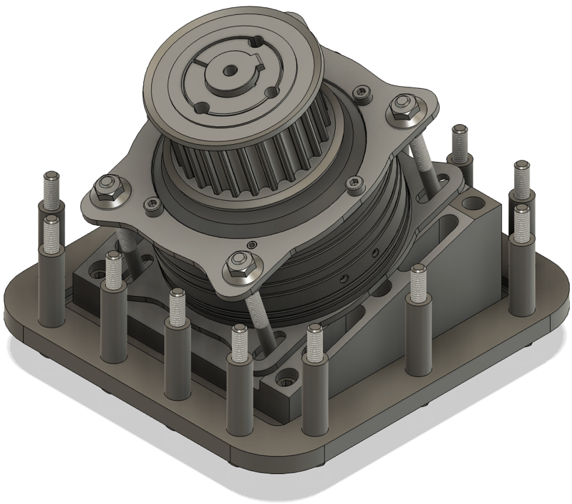

1. For this stage, obtain the subassembly from the previous stage (**S10**).
2. Gather fourteen inserts.
3. Measure the inserts to ensure they have the same dimensions.
4. Locate the bolts that extend from **R05.**
5. Simply sink the inserts on to protruding bolt lengths pattern.
6. Refer to the figure above to ensure the outcome.

# S11 – Insert Installation SA11

|  |  |  |  |
| --- | --- | --- | --- |
| Reference | Material | Dimensions (mm) | Quantity |
| S10 | Insert Installation SA10 | - | 1 |

Instructions to follow, prior to assembly:   
Must gain access to the car after the required cutouts have been performed on the front cockpit.

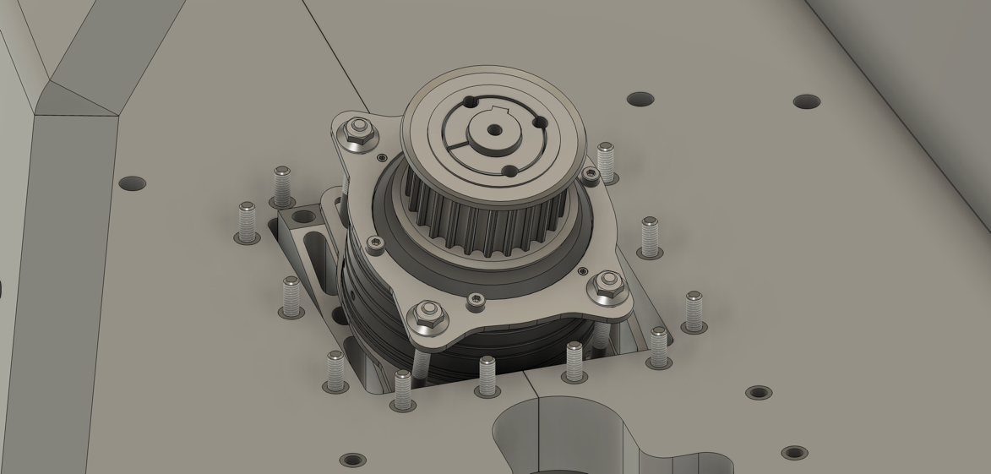

Note: The car must be raised above a certain height from the ground to achieve the next step.

1. Identify the arrangement of holes situated around the rectangular cutout that is ahead of the cutout reserved for the steering shaft.
2. Measure the dimensions of the cutout.
3. Verify that the geometry of hole arrangement of the cutout & the bolt pattern are the same.
4. Use a scissor lift or a suitable hoist to raise the cockpit from the ground.
5. Ensure that the height is adequate for safe access.
6. Orient **S10** with the top face of **R08** facing upwards.
7. With the help of a team member, carefully place **S10** on the base of a hydraulic jack.
8. Begin to lift the **S10**, via jack.
9. Align the *M6* bolts of **S10** with the corresponding holes in the cockpit floor.
10. Request another team member to validate the position of the **S10**.
11. Ensure that **S10** will fit in the cutout of the front cockpit.
12. Confirm that all bolts, and inserts have successfully passed through all the holes on the cockpit floor.
13. Push **S10** firmly against the underside of the cockpit.
14. Ensure that the top face of **R05** is firmly held against the exterior underside of the floor.

Note: As depicted by figure 1, once in position, all bolts must now be visible from inside the cockpit.

# S12 – Backing Plate Installation SA12

|  |  |  |  |
| --- | --- | --- | --- |
| Reference | Material | Dimensions (mm) | Quantity |
| R06 | Motor Mount Backing Plate | - | 1 |
| S11 | Insert Installation SA11 | - | 1 |

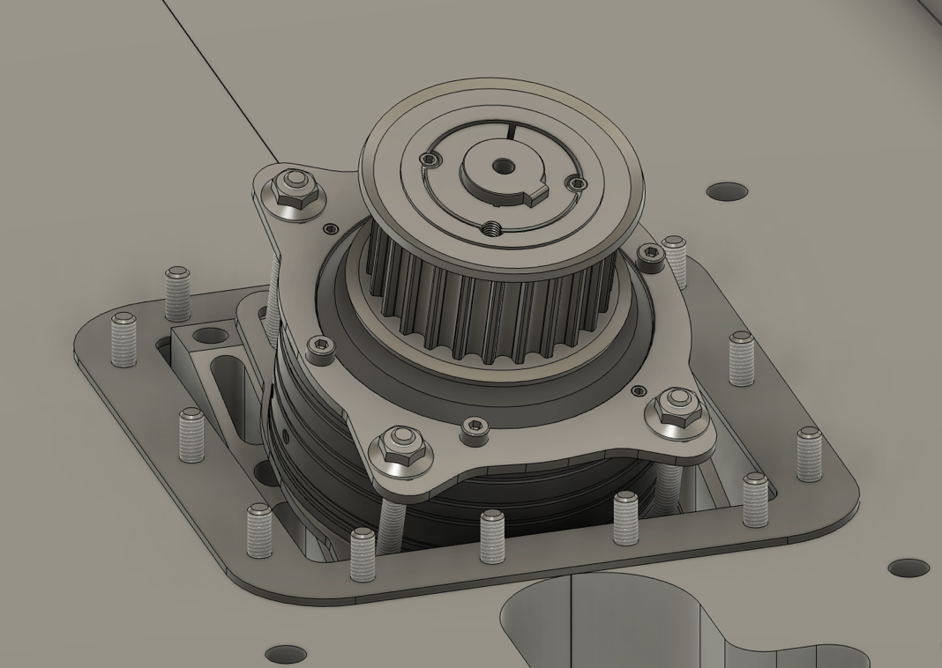

1. Continue using the jack to maintain the prevailing position of **S11.**
2. If possible, allocate a team member to further secure the position of **S11**on the jack.
3. View the assembly from front of the cockpit.
4. Note the extended *M6* bolts that emerge from floor of the cockpit.
5. Obtain the Mount Backing Plate (**R06**).
6. Align the hole sequence on the **R06** against that of the *M6* bolts.
7. Measure the dimensions of Mount Backing Plate.
8. Verify that the geometry of hole arrangement between **R06** & the bolt pattern are the same.
9. Drop the **R06** into place.
10. Ensure that the backing plate sits flat on the inner floor of the cockpit.

# S13 – System Clamping SA13

|  |  |  |  |
| --- | --- | --- | --- |
| Reference | Material | Dimensions (mm) | Quantity |
| F04 | Hex Flange Nut | M6 × 1 | 14 |
| S12 | Backing Plate Installation SA12 | - | 1 |

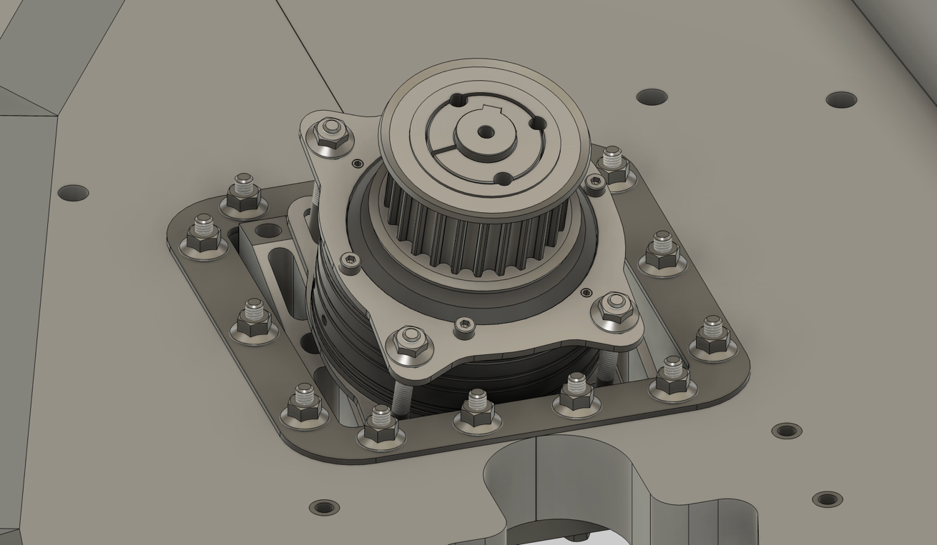

1. Continue using the jack to maintain the prevailing position of **S12.**
2. Note the exposed ends of the **F05**.
3. Gather the corresponding hex flange nuts (**F04**).
4. Obtain a torque wrench with an extension compatible with *M6* bolt heads.
5. Begin threading the nuts along the bolts situated on the corners of the pattern.
6. One by one, twist each nut along the available length of **F01.**
7. Work your way through the remainder of the bolts.
8. Proceed to clamp the **S11** against the floor of the cockpit with the backing plate as the immediate mounting face.
9. Ensure the clamping force doesn’t exceed the axial load bearing capacity of the fastener.

Note: The subassembly must now be rigidly clamped against the cockpit.

# Nomenclature & Document Navigation

## Reference Codes & Terminology

* To track components with relative ease, reference codes have been adapted for all components that contribute to the assembly. The codes include ‘R’ for design components, ‘F’ for all fasteners, ‘S’ for the subassemblies, and ‘T’ for the tools required during assembly.
* The entire assembly has been dissected into several subassemblies, with step-by-step instructions guiding each assembly process.
* Each subassembly component of the installation guide consists of a table in the format of:

|  |  |  |  |
| --- | --- | --- | --- |
| Reference | Material | Dimensions (mm) | Quantity |

* The table headers primarily convey the materials and quantity required for each subassembly.
* As per the example provided below.

|  |  |  |  |
| --- | --- | --- | --- |
| Reference | Material | Dimensions (mm) | Quantity |
| R01 | AK 10-9 BLDC Motor | Refer manufacturer datasheet | 1 |
| R07 | Motor Shaft | Refer parent table | 1 |
| F04 | Hex Flange Nut | M6 × 1 | 14 |
| F07 | Hex Socket Head Screw | M5 × 0.8 × 20 | 6 |
| S03 | Motor Mount & Base Plate SA3 | - | 1 |
| S07 | Pulley Preparation SA7 | - | 1 |

* Where “R01” is design component 1, “F04” is fastener 2, and “S03” is subassembly 3.
* The term “SA” is an acronym for Subassembly.
* Tables will be listed in the order, starting from Design components (‘R’), then fasteners ('F’), and subassemblies (‘S’) which are composed as you progress though the installation guide.
* All immediate fastener dimensions will be included throughout the document.
* In the case where the dimensions are not directly available, corresponding drawings maybe be provided for reference.
* Each table of components respective to the subassembly will ONLY consist of the material and quantities that are required for that specific subassembly.
* The parent table on page 1, consists of all components with their (exact) collective quantities as similar to a bill of materials.
* The “Reference” column will always have the reference number (ID) of the component. The “Material” column always depicts the name of the component. The “Dimensions” & quantity are physical measurements provided for further component identification and clarity.
* Lastly, the image(s) in each subassembly instruction is intended for reference, as it’s an illustration of what the finished subassembly (respective to that subassembly) must look like.